How the site works
Five HTML pages, no build step, no database, no server. Everything a visitor sees is a static file. The one exception is a single function that keeps an API key secret.
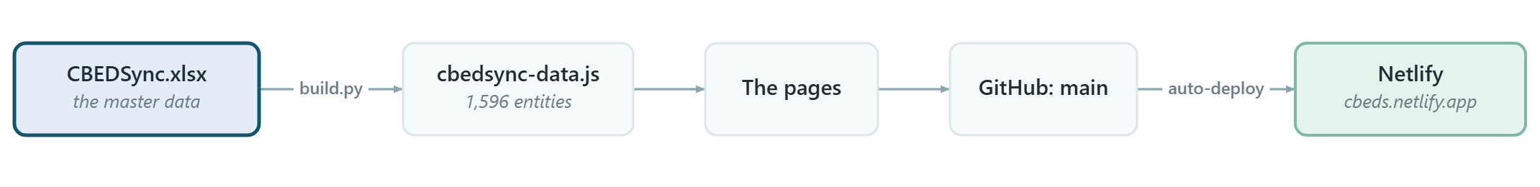
Edit the Excel -> run one `.bat` -> the site changes. Nothing else touches the data.

The five pages
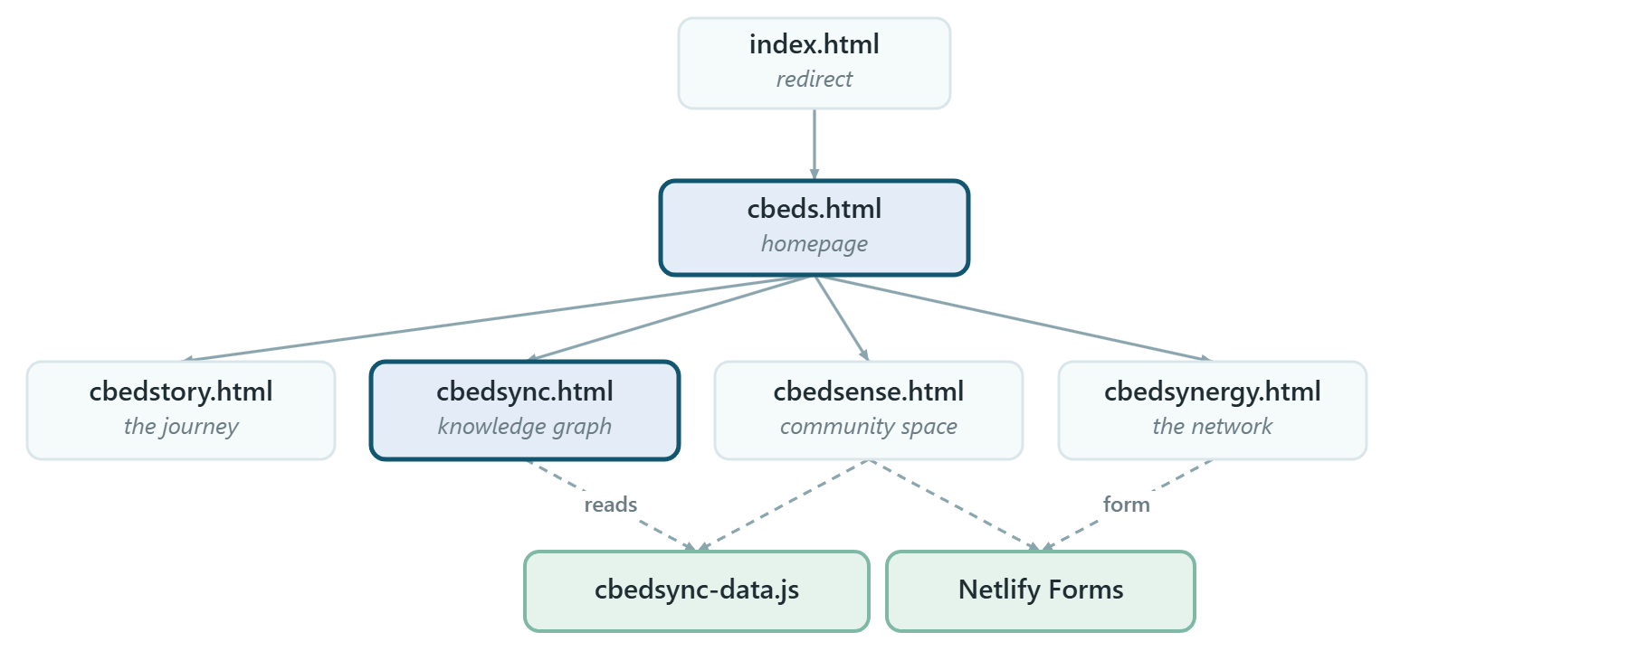
Only CBEDSync and CBEDSense load the data file - 143 KB gzipped. The other three are self-contained, so they stay light.
Each page opens with a full-screen hero built from the same --hero-h variable, with its own canvas or SVG artwork underneath the copy.

Where the data comes from
build.py reads four sheets of draft/CBEDSync.xlsx and writes one file. It never writes back.
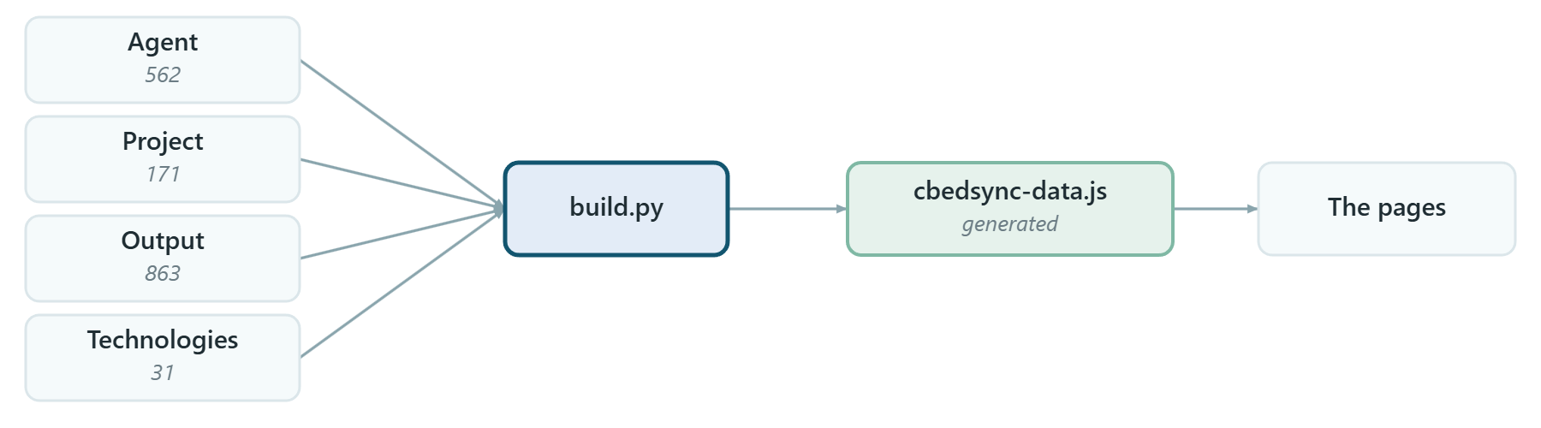
`cbedsync-data.js` is generated - never edit it. Every .bat overwrites it.
Fields are read by position, so a column inserted mid-sheet shifts everything after it and the build will publish a wrong graph without complaining. New columns go at the far right. (Source is the one exception - found by its heading.)

Publishing
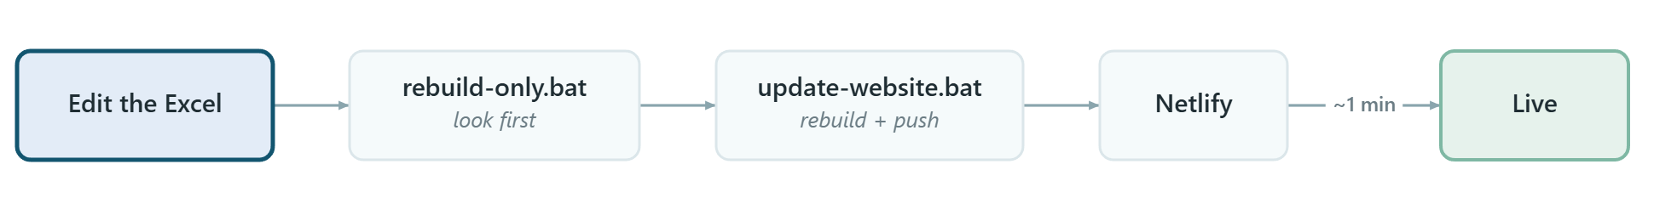
Netlify redeploys on every push to main. There is no build command - it copies the files as they are.

The one piece of server code
"Ask the graph" on CBEDSync answers from the graph in the browser. If an API key is set, netlify/functions/ask.mjs adds a short AI-written paragraph per section.
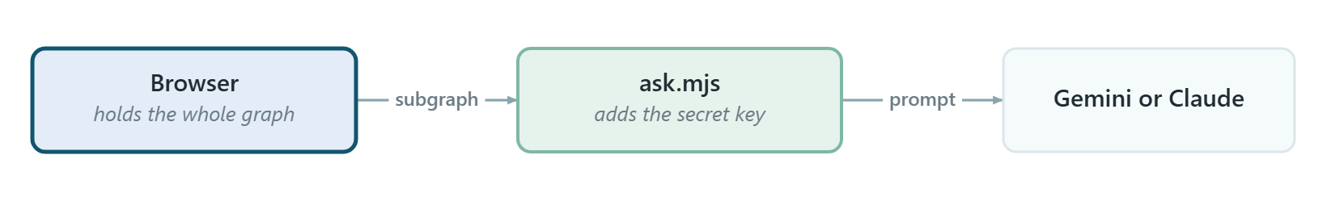
The key lives only in Netlify's environment variables - never in a page, because every .html and .js file is public. Without a key the page falls back to its own answers, so nothing breaks.

Submissions
Two forms collect entries from outside the team. Nothing they send reaches the site without a person copying it into the Excel - see Handling submissions.

Files that matter
draft/CBEDSync.xlsx | the master data - edit this
cbedsync-data.js | generated, 143 KB gzipped, don't edit
build.py | Excel to data file
*.bat | rebuild / publish / collect submissions
cbeds-assistant.js | shared "ask the graph" engine (CBEDSync + CBEDSense)
netlify/functions/ask.mjs | the only server code; holds no key
.env | your local keys - git-ignored, never published

Setup and hosting: HOW-TO-HOST-AND-UPDATE.md.
Generated from HOW-THE-SITE-WORKS.md. Edit the Markdown, not this file - the diagrams here are pictures and will go stale on their own.

